Running head: BIDIRECTIONAL EFFECT OF PRIMING ON LEXICAL DECISIONS

Bidirectional Effect of Priming on Lexical Decisions
Concerning Varying Degrees of Ambiguity
Justin F. Gerle
Carnegie Mellon University

Abstract
The effect of priming on lexical decision-making was investigated. Forty college students (20 men and 20 women) were separated by weight and presented with sixteen different word pairings. The pairings were based upon four commonly known lexical associations; three uncommon alternative pairs were introduced for each pair, as well. Reaction times to the cues varied between the four possible types of combination, with the commonly primed target yielding the smallest – as predicted by prior research. Variety amongst the other three pairs suggests different degrees of impediment, possibly based upon the degree of confounding presented by a false target. Blatantly false targets yielded lower reaction times than targets which more closely resembled the true target.

Bidirectional Effect of Priming on Lexical Decisions
Concerning Varying Degrees of Ambiguity
The theory of priming – that certain stimuli activate related nodes within the mind – is widely accepted in the field of psychology. Specific research into priming has shown that commonly associated word pairs exhibit priming effects (Meyer & Schvaneveldt, 1971). More specifically, the automatic priming process involved in lexical decision making facilitates faster response if the target word (e.g., butter) follows a related prime (e.g., bread) as opposed to an unrelated prime (e.g., candy) (Pecher, Zeelenberg & Raaijmakers, 2002). The presence of strategies has also been posited in priming; expectancy-based strategy contends that identification of a prime generates an expectancy. If the expectancy is correct, priming yields a benefit in response, whereas an incorrect expectation yields a cost (Neely, 1976). Little attention has been given to ambiguous stimuli between the realms of the two, however. This study thus proposed to examine the relationship among correct, incorrect and less salient incorrect responses.
The lexical decision effects of priming speed response to expected targets and inhibit response to unexpected targets. This is due to the activation of a specific node due to common association with the prime (e.g., bread activates butter). As the mind is already focused on such a response, a different, unexpected response requires the mind to back up out of the activated nodal pathway, thus affecting an inhibitory cost. More than one possibility exists for unexpected responses, however. For example, a correct response which is not commonly associated with the prime would invite initial rejection and subsequent reevaluation, thus further increasing inhibition. Similarly, an incorrect response which highly resembles the prime would initially be accepted, only to be rejected after some additional thought. Therefore, this study proposed that response times in lexical decision making would exhibit a variety of means based upon the identity of the target following the prime; specifically, according to the amount of cognition necessary to arrive at a decision, primed correct targets would induce the lowest time, followed by unprimed incorrect, primed incorrect and unprimed correct targets, respectively.
Method
Participants
Twenty male and 20 female undergraduate students drawn from the participant pool at Carnegie Mellon University each received one credit for participation. All were between 17 and 23 years of age (mean age = 19.6 years), were born in the United States, and were raised in English speaking families. The male and female categories were split along mean weights into hearty (mean weight = 232 pounds) and skimpy (mean weight = 168 pounds) groups, with 10 males and 10 females in each group.
Apparatus
The testing program was constructed on E-Prime. Instructions informed participants that they would see two words, and should respond with “1” if both were foods and “2” if they were not. The program then presented four commonly known American word pairs which dealt with food (e.g., meat and potatoes) with four possible targets following the stimuli. The sequence of stimuli presentation was priming word-mask-target. In addition to the commonly primed target, an incorrect non-word target which resembled the common prime (e.g., patatoes), an incorrect unprimed target (e.g., wall), and a correct unprimed target (e.g., salad) were also presented, for a total of sixteen possible combinations.
Procedure
Participants were tested individually and viewed all sixteen word pair combinations in random order. Reaction times were measured from initiation of the target stimulus to participant response; incorrect responses were discarded when collecting response times. This application of the apparatus yielded eight possible cells for the study in three dimensions: weight, priming, and correctness.
Results
As previously stated, only correct responses on the part of the participant were used to determine reaction times. For the hearty category, mean reaction times were 448ms for food primes, 662ms for non-food primes, 596ms for food non-primes, and 547ms for non-food non-primes. The skimpy category was less extreme in its divergence. With an alpha level of .05, ANOVA indicated no main effect for weight F(1) = .21, p>.05, prime F(1) = .98, p>.05, or food F(1) = 3.8, p>.05. There was, however, a highly significant interaction between food and prime F(1) = 20.1, p<<.05. This interaction is readily apparent in Figure 1.
Discussion
The results of the present study suggest that the specific identity of the target following a prime does have a varying effect upon reaction time in a lexical decision process. While food or priming does not exhibit a noticeable effect in and of itself, when the two are integrated there is a noticeable variation in the resultant reaction times. The data are too limited to propose a definite hierarchy or responses, but the means do allude to the fact that the hypothesis originally stated may be partially if not wholly correct. These data are, needless to say, in dire need of further examination and replication. Larger participant bases, more numerous lexical pairs, and possible alteration to the exact methodology of the program could yield more precise and powerful results.

Figure Caption Page
Figure 1 – Mean reaction times recorded as partitioned by weight, presence of food
(correctness), and presence of priming.

Figure 1
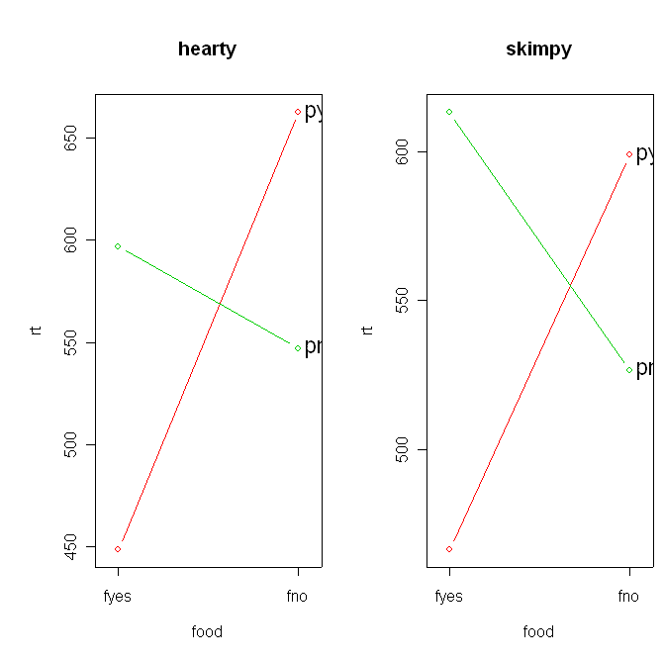

References
Meyer, D. E., & Schvaneveldt, R. W. (1971). Facilitation in recognizing pairs of words:
Evidence of a dependence between retrieval operations. Journal of Experimental
Psychology, 90, 227-234.
Neely, J. H. (1976). Semantic priming and retrieval from lexical memory: Evidence for
facilitory and inhibitory processes. Memory & Cognition, 4, 649-654.
Pecher, D., Zeelenberg, R., & Raaijmakers, J. G. W. (2002). Associative priming in a
masked perceptual identification task: Evidence for automatic processes. The
Quarterly Journal of Experimental Psychology, 55A(4), 1157-1173.

